|  |  |
| --- | --- |
| **Assignment Case** |  |
| COMP6183 | COMP6543001  Secure Web Programming | Secure Programming |
| **Cyber Security** | **O223-COMP6543-WT01-01** |
| ***Valid on*** *Odd Semester Year 2021/2022* | **Revision 00** |

1. Seluruh mahasiswa tidak diperkenankan untuk:

*All students are not allowed to:*

* + - Berdiskusi dan/atau bekerja sama dengan mahasiswa lainnya

*Discuss and/or work together with other student participants*

* + - Melihat sebagian atau seluruh jawaban mahasiswa lain

*Seeing a part or the whole answer from another student*

* + - Membuka dan menyalin dari **BUKU** atau **CATATAN**, **VIDEO** dari pengajar (recording kelas, VBL, Youtube, dsb) dan **REFERENSI** lainnya

*Open and copy from any resources such as notes, videos (class recording, VBL, Youtube, etc) and other references*

* + - Membuka dan menyalin jawaban dari internet (google, stackoverflow, dsb)

*Open and copy answer from the internet (google, stackoverflow, etc)*

* + - Mengerjakan soal yang tidak sesuai dengan tema yang ada di soal,

*Working with another theme which is not in accordance with the existing theme in the matter of the case,*

* + - Melakukan tindakan kecurangan lainnya,

*Committing other dishonest actions,*

* + - Secara sengaja maupun tidak sengaja melakukan segala tindakan kelalaian yang menyebabkan hasil karyanya berhasil dicontek oleh orang lain / kelompok lain.

*Accidentally or intentionally conduct any failure action that cause the results of the project was copied by someone else / other groups.*

1. Jika mahasiswa terbukti melakukan tindakan seperti yang dijelaskan butir 1 di atas, maka **nilai mahasiswa** yang melakukan kecurangan (menyontek maupun dicontek) akan di – **NOL** – kan.

*If the student is proved to the actions described in point 1 above, the score of the student which committed dishonest acts (cheating or being cheated) will be “Zero”*

1. Perhatikan jadwal pengumpulan jawaban, segala jenis pengumpulan jawaban di luar jadwal tidak dilayani.

*Pay attention to the submission schedule, all kinds of submission outside the schedule will not be accepted*

1. Bila Anda tidak membaca peraturan ini, maka Anda dianggap telah membaca dan menyetujuinya

*If you have missed to read these regulations, so you are considered to have read and agreed on it*

1. Persentase penilaiaan untuk matakuliah ini adalah sebagai berikut:

*Marking percentage for this subject is described as follows:*

|  |
| --- |
| **Tugas Mandiri**  *Assignment* |
| 100% |

1. Software yang digunakan pada matakuliah ini adalah sebagai berikut:

*Software will be used in this subject are described as follows:*

|  |
| --- |
| **Software**  *Software* |
| Chrome / Firefox / Microsoft Edge  Visual Studio Code  XAMPP 8.0.7  jQuery 3.6.0 |

## Ekstensi file yang harus disertakan dalam pengumpulan tugas mandiri untuk matakuliah ini adalah sebagai berikut:

*File extensions should be included in assignment collection for this subject are described as follows:*

|  |
| --- |
| **Tugas Mandiri**  *Assignment* |
| PHP, HTML, CSS, JS, SQL, Image Files (JPG / PNG), HTACCESS |

## Soal

*Case*

**Literal Garage Sale**

**Literal Garage Sale**, as the name implies, sells garages, literally. You, as a programmer, are asked to **create the website’s prototype** to gather more information before developing the real website to enhance quality. The following are the prototype website’s requirements:

1. **Home Page (index.php)**
   * + This page can be accessed by anybody
     + Show the following **navigation menu** for **guests**:
       - “Welcome, Guest!” message
       - Home
       - Login
     + Show the following **navigation menu** for **users**:
       - “Welcome, [user name]!” message
       - Home
       - Add New Garage
       - Logout
     + Show every garage from the database with the following information:

* **Garage Name**
* **Garage Price**
* **Garage Image**
  + - The **log out** menu will **destroy the user’s session** and **generate a new session id.**
    - If the user is logged in, show **Purchase button** with the following criteria:
      * + If the user is currently **logged in,** then **they can purchase (delete) every garage.**
        + If **Purchase** button is clicked, **the garage will be removed from database.**

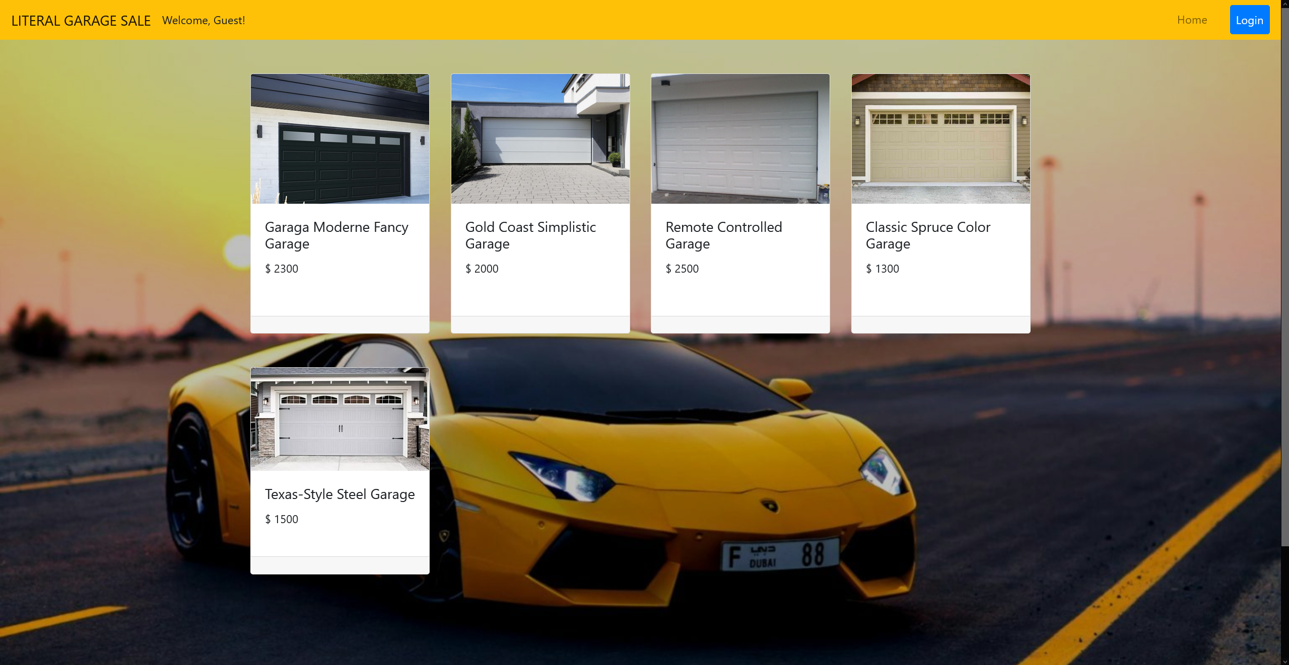

**Figure 1. Home Page for guests**

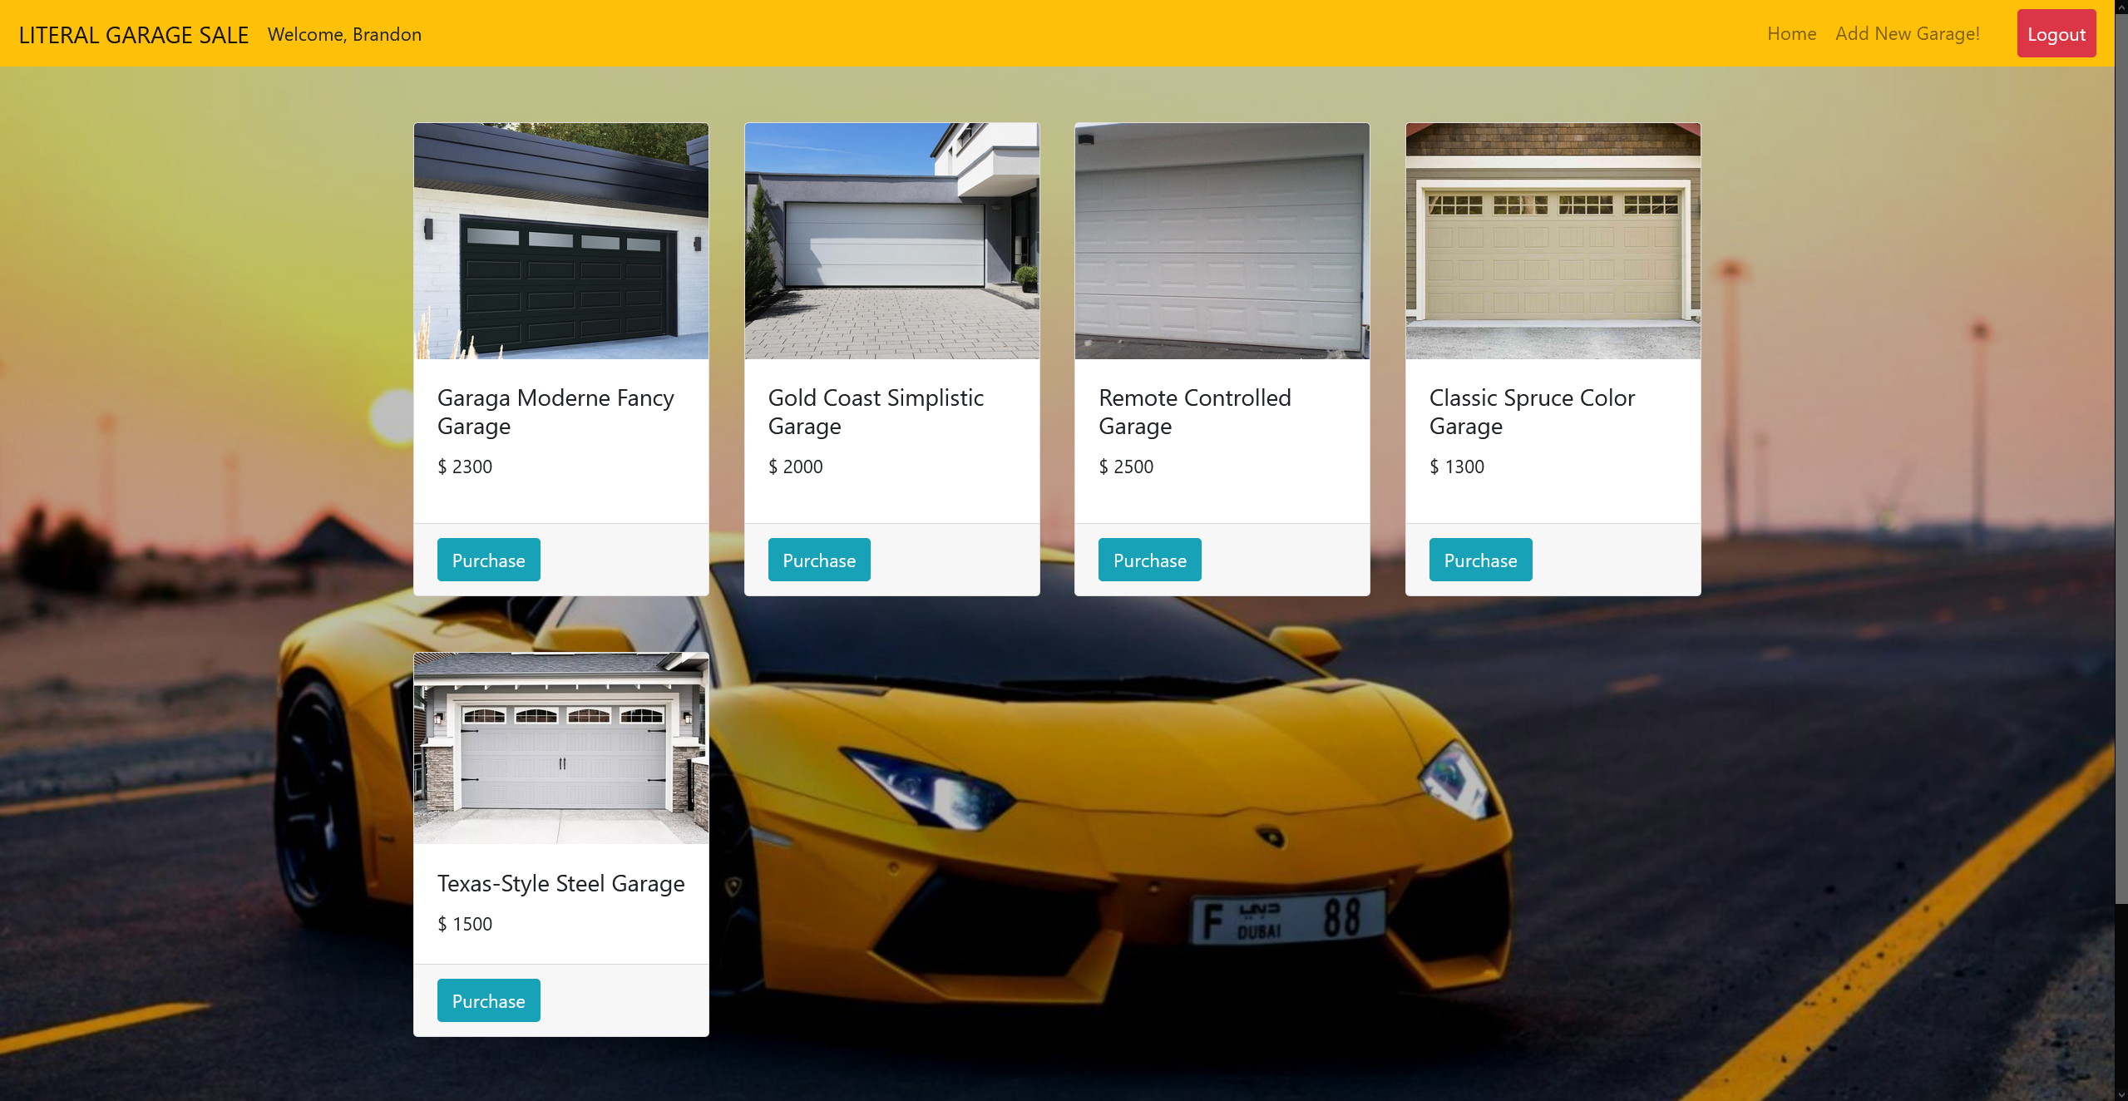

**Figure 2. Home Page for users**

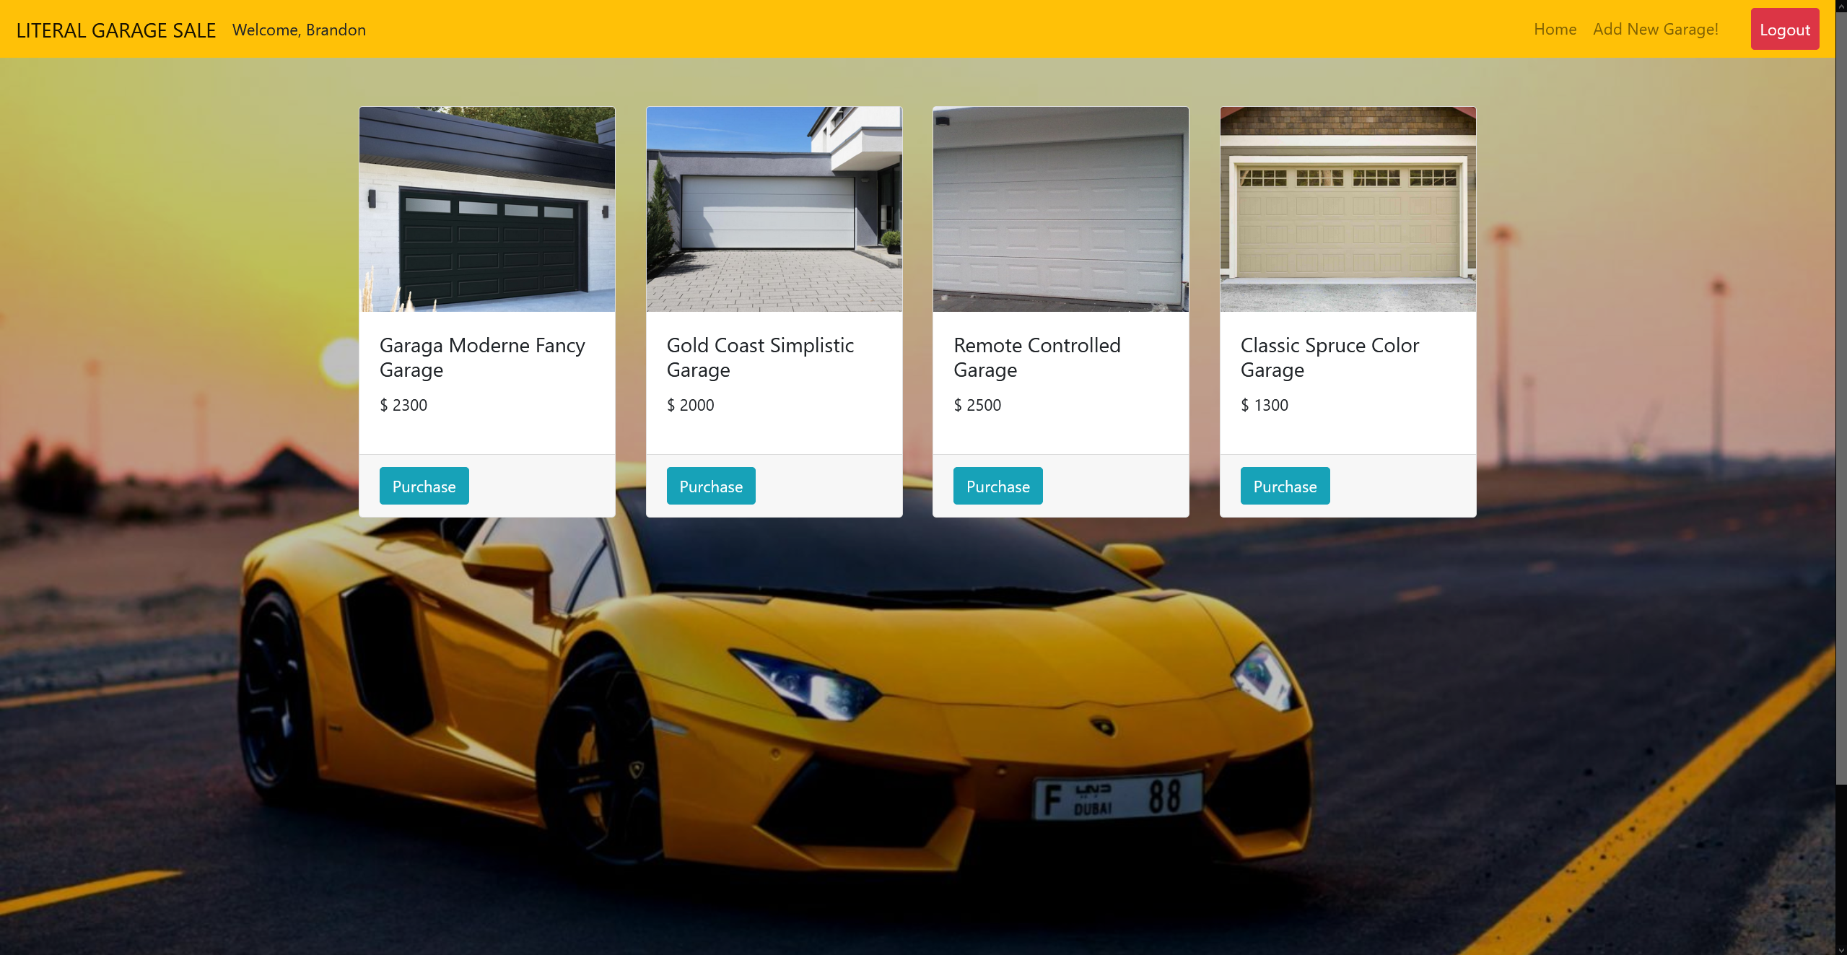

**Figure 3. Home Page for users, after purchasing a garage**

1. **Login Page (login.php)**
   * + This page **can only be accessed by guests**, if logged in user access this page, **redirect** them to **home page.**
     + This page contains of a form with the following component:

* Email Textbox
* Password Textbox
* Login Button
  + - If the user clicks on the Login button, then validate:
* If **Email** field is **empty**, then show “**[!] Error: Email must be filled!**” error message.
* If **Password** field is **empty**, then show **“[!] Error: Password must be filled!”** error message.
* If **Email and password combination** is **not registered** in database, then show “**[!] Error: Invalid email and password combination!**” error message
* The following are **credentials** already stored in the database:

|  |  |
| --- | --- |
| Email | Password |
| [coolbrandon89@gmail.com](mailto:coolbrandon89@gmail.com) | brandoniscool |
| [jennywashere@gmail.com](mailto:jennywashere@gmail.com) | cuteymccuteface |

* + - If user successfully logged in, then the **user information will be stored in a session** and after that, **user will be redirected to Home Page.**
    - **Generate new session id** after the user **has successfully logged in.**

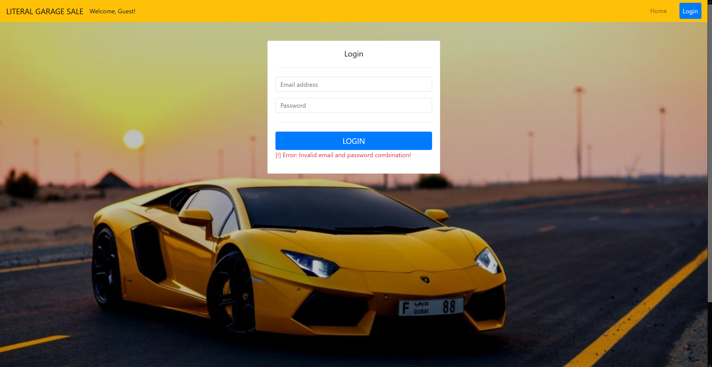

**Figure 4. Log In Error Message**

1. **Add New Garage Page (add.php)**

* This Page can only **be accessed by users**, if **guests** try to access this page, **redirect them to Home page.**
  + - This page contains of a form with the following component:
* Garage name Textbox
* Garage price Textbox
* File Input
* Add Button
  + - If the user clicks on the Post button, then validate:
* If **Garage name** is **empty**, show “**[!] Error: Garage name must be filled!**” error message
* If **Garage name** is **less than 5 characters long**, then show “**[!] Error: Garage name must be at least 5 characters long!**” error message
* If **Garage name** **does not end with ‘ Garage’**, then show “**[!] Error: Garage name must end with ‘ Garage’!**” error message
* If **Garage price** is **0 or less**, then show “**[!] Error: Garage price must be more than 0!**” error message
* Allowed File Extensions: **.jpg, .jpeg, .png**
* If **file extension is not among allowed file extensions**, show “**[!] Error: Garage image must be a ‘jpg’, ‘jpeg’, or ‘png’!**” error message.
* If there is no error, make sure data is **inserted in the database** and the **File must be stored in the server.**

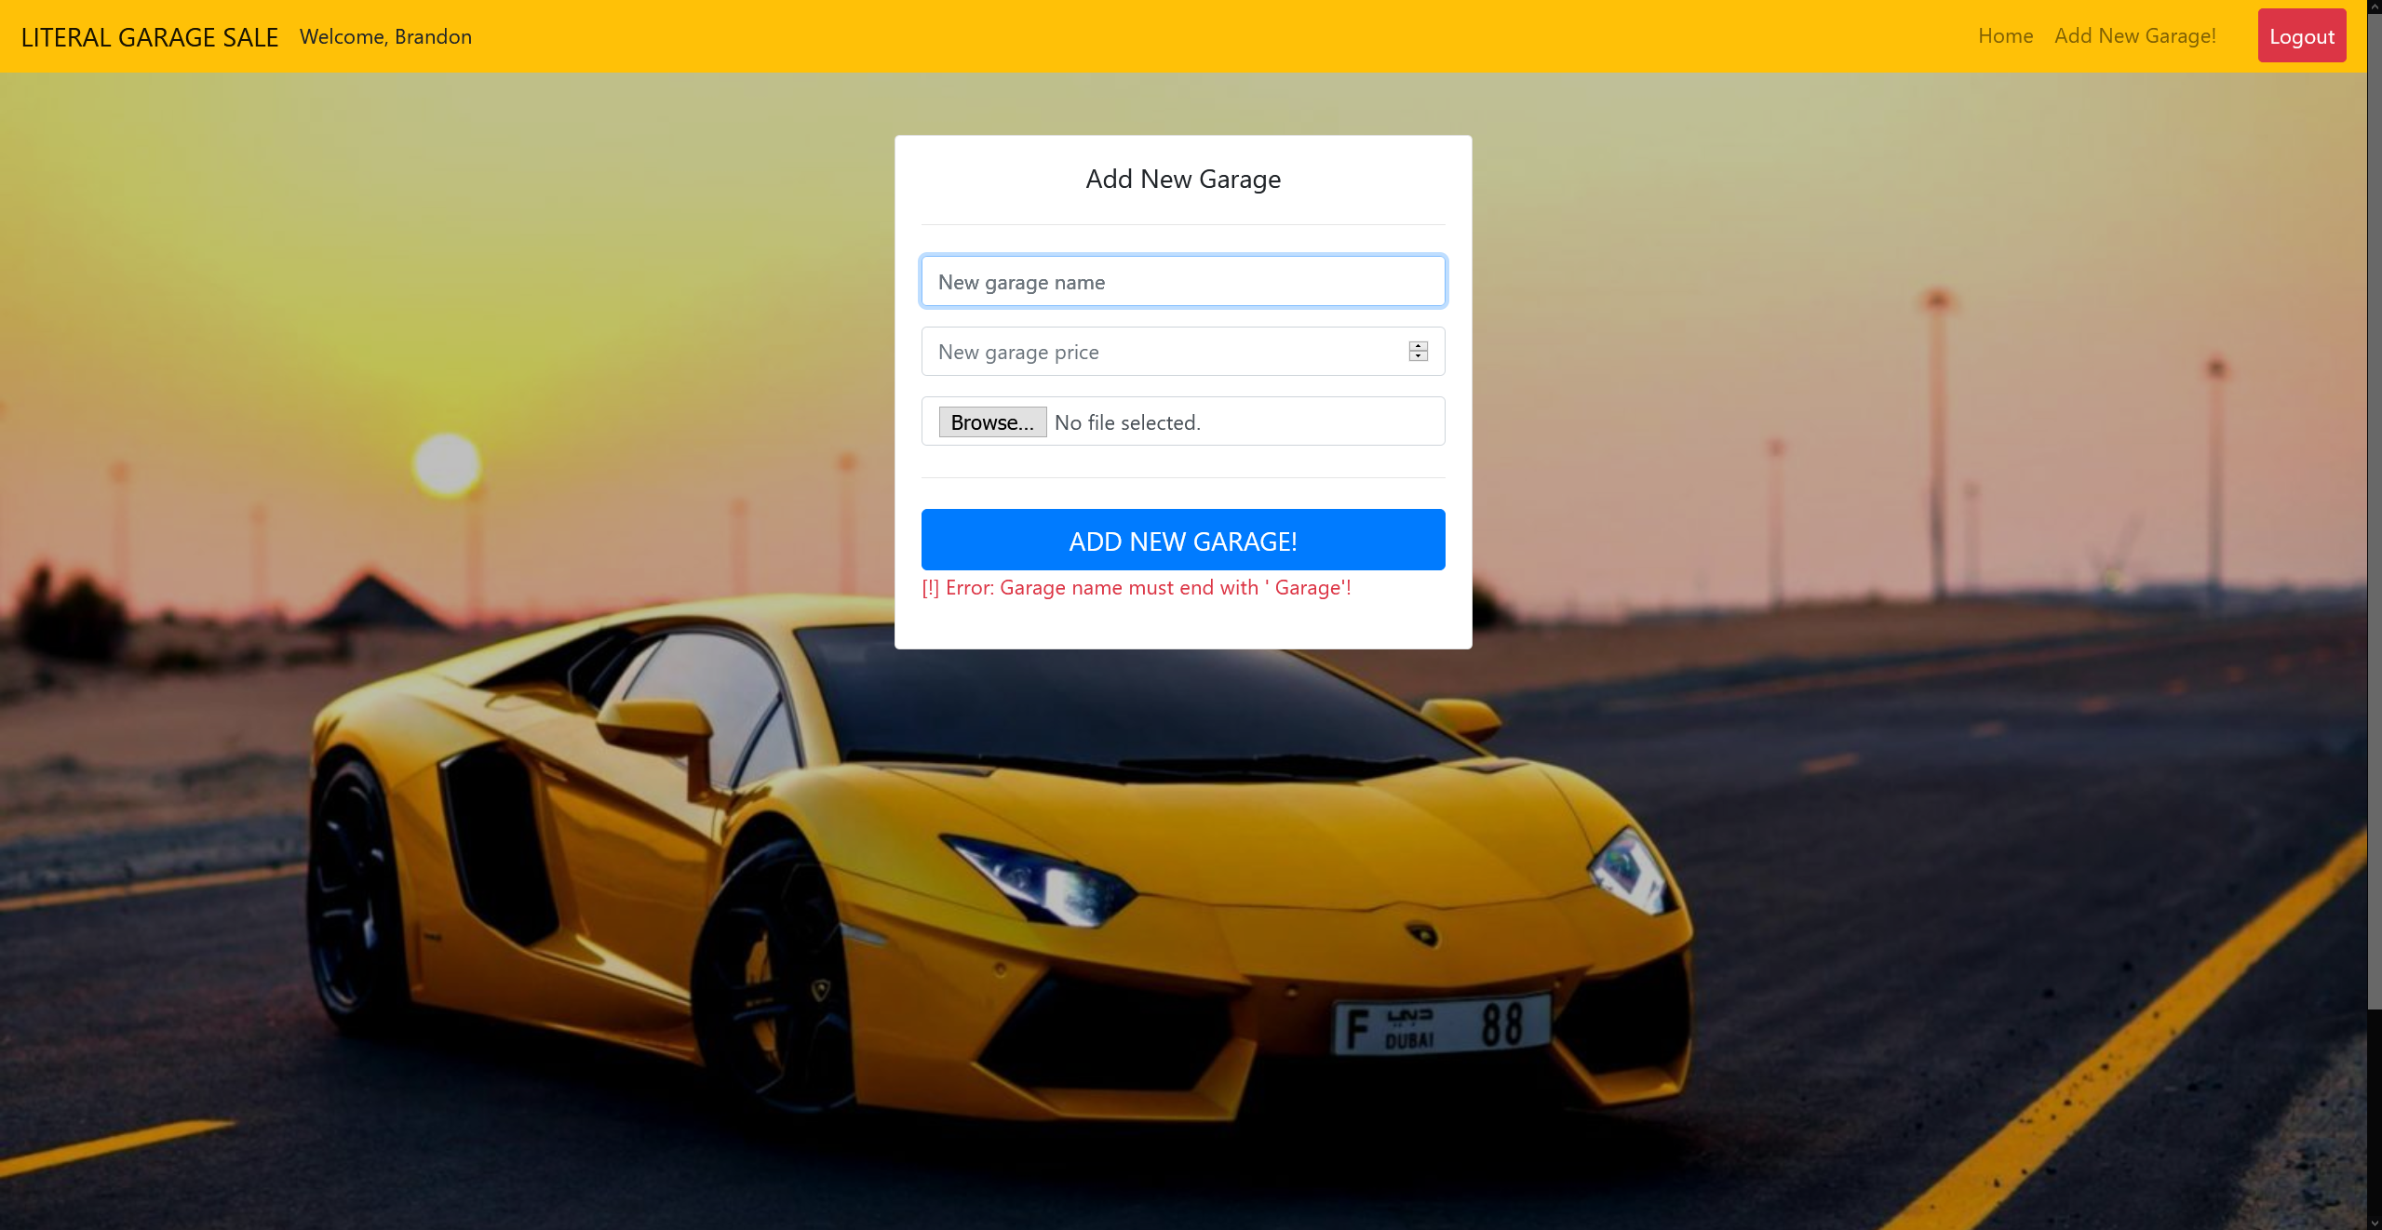

**Figure 5. Title Error Message**

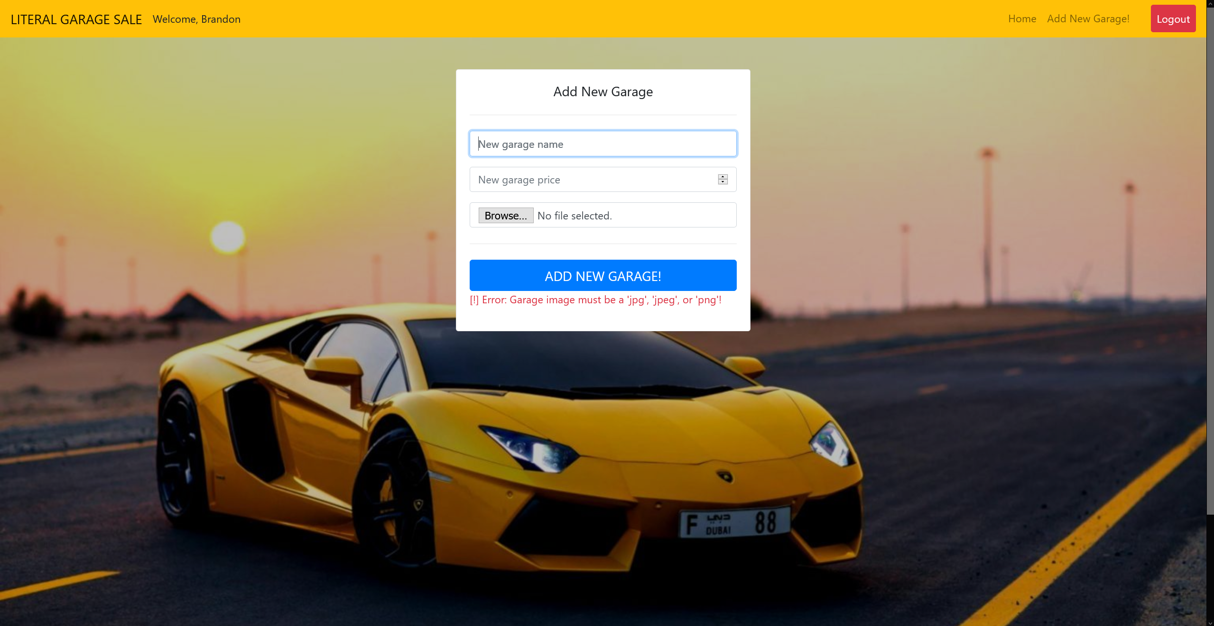

**Figure 6. File Extension Error Message**